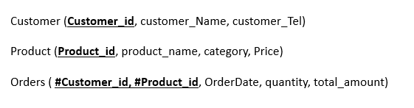

SQL

INSERT INTO CUSTOMER (Customer_id, Customer_Name, Customer_Tel)

VALUES ('C001', 'John Doe', 1234567890);

INSERT INTO CUSTOMER (Customer_id, Customer_Name, Customer_Tel)

VALUES ('C002', 'Jane Doe', 9876543210);

INSERT INTO CUSTOMER (Customer_id, Customer_Name, Customer_Tel)

VALUES ('C003', 'Peter Jones', 1112223333);

SQL

INSERT INTO PRODUCT (Product_id, Product_Name, Price, Category)

VALUES ('P001', 'Laptop', 1200, 'Electronics');

INSERT INTO PRODUCT (Product_id, Product_Name, Price, Category)

VALUES ('P002', 'Smartphone', 600, 'Electronics');

INSERT INTO PRODUCT (Product_id, Product_Name, Price, Category)

VALUES ('P003', 'T-shirt', 20, 'Clothing');

SQL

INSERT INTO ORDERS (Customer_id, Product_id, Quantity, Total_amount, OrderDate)

VALUES ('C001', 'P001', 1, 1200, SYSDATE);

INSERT INTO ORDERS (Customer_id, Product_id, Quantity, Total_amount, OrderDate)

VALUES ('C002', 'P002', 2, 1200, SYSDATE);

INSERT INTO ORDERS (Customer_id, Product_id, Quantity, Total_amount, OrderDate)

VALUES ('C003', 'P003', 3, 60, SYSDATE);

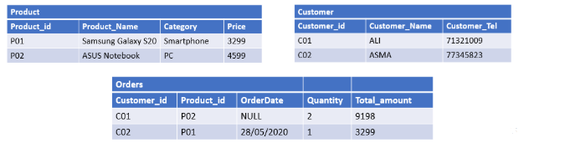

TABLE PRODUCT

INSERT INTO PRODUCT (Product_id, Product_Name, Price, Category)

VALUES ('P01', 'Samsung Galaxy 520', 3299, 'Smartphone');

INSERT INTO PRODUCT (Product_id, Product_Name, Price, Category)

VALUES ('P02', 'ASUS Notebook PC', 4599, 'Laptop');

TABLE CUSTOMER

INSERT INTO CUSTOMER (Customer_id, Customer_Name, Customer_Tel)

VALUES ('C01', 'ALI', 71321009);

INSERT INTO CUSTOMER (Customer_id, Customer_Name, Customer_Tel)

VALUES ('C02', 'ASMA', 77345823);

TABLE ORDERS

INSERT INTO ORDERS (Customer_id, Product_id, Quantity, Total_amount, OrderDate)

VALUES ('C01', 'P02', 2, 9198, NULL);

INSERT INTO ORDERS (Customer_id, Product_id, Quantity, Total_amount, OrderDate)

VALUES ('C02', 'P01', 1, 3299, '2020-05-28');